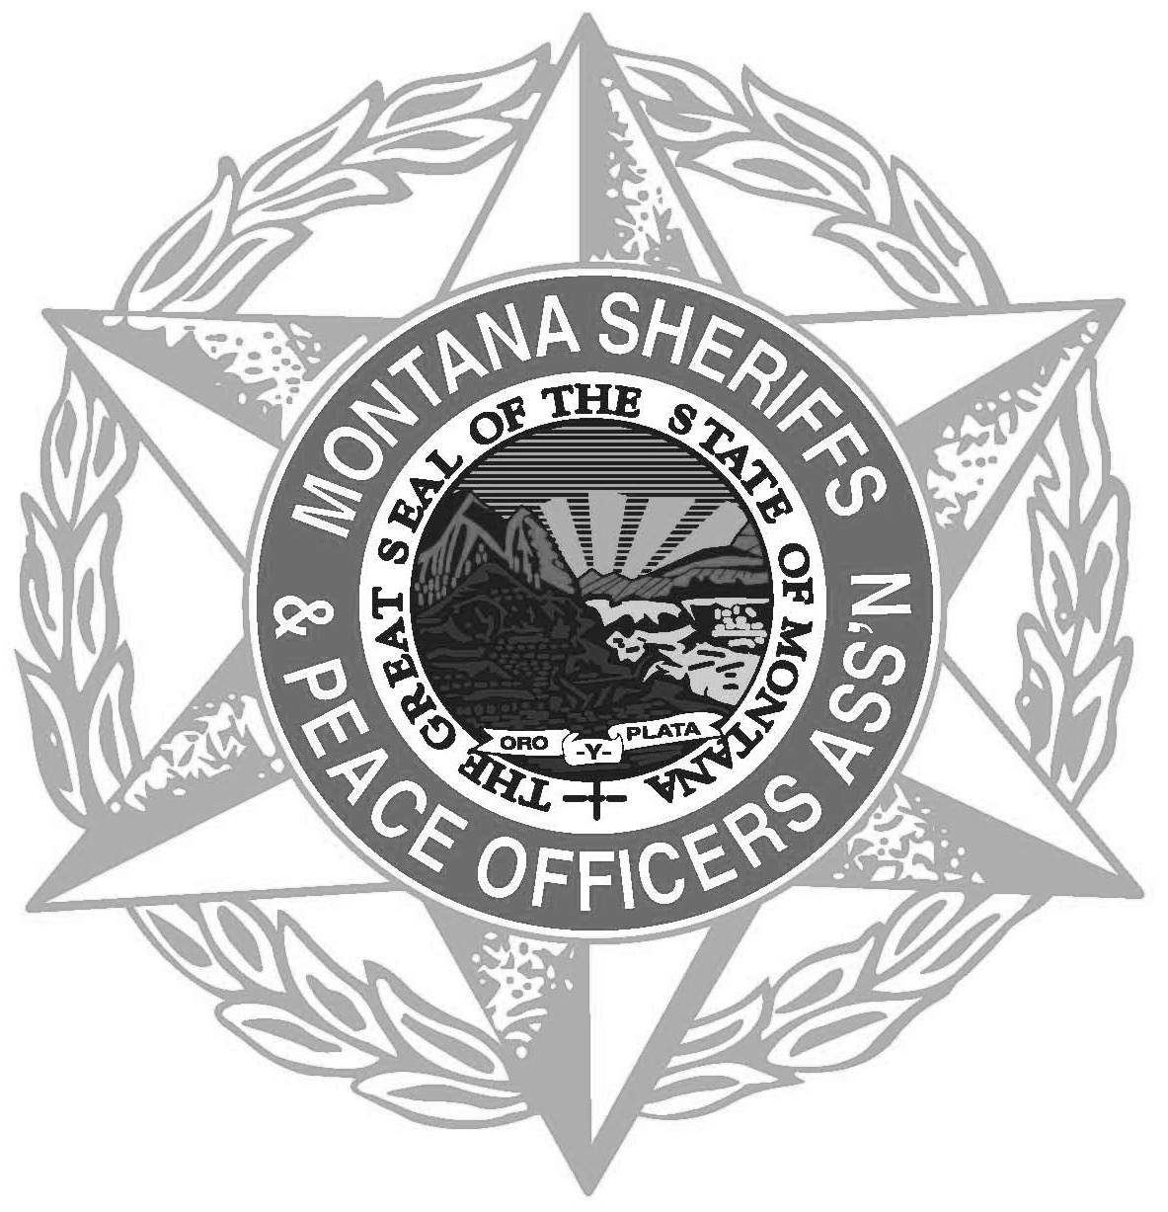
Montana Sheriffs & Peace
Officers Association
PO Box 794 • Helena, MT 59624
(406) 443-5669 • www.mspoa.org

The Montana Sheriff’s and Peace Officer Association announces the availability of two $1500.00 scholarships to be awarded for the fall semester of 2022 to a graduating high school senior who is seeking a career in local law enforcement OR a current college student who is pursuing a career in local law enforcement. Recipients will be selected on the basis of need and academic ability as well as career goals.

Eligibility requirements are as follows:
- High school graduate or successful GED completion.

- Must be able to meet basic peace officer eligibility requirements as established by Montana statute and the Montana Peace Officers Standards and Training Council (MCA 7-32-303) (23.13.2 – POST Certification).

- Must have a high school grade point average of at least 2.5 and preferably plans to be enrolled as a full-time student in a Montana based college or university that offers a minimum AA degree in the Criminal Justice Field. OR must have a current college/university grade point average of at least 2.5 and be pursuing a degree in the Criminal Justice Field.

- High School students applying for the fall scholarship must submit proof on enrollment intentions in a university or college. College Students must submit proof of enrollment at his/her current university or college.

- When applying for a scholarship, please include the following:
- Letter requesting consideration as an applicant.
- Current High School transcript OR Current College/University Transcript.
- Personal resume including references.
- Outline of career goals.
- Recent Photograph.
- Statement of how you are currently financing your college education.
- Letter from high school or college advisor verifying your academic abilities and attesting to the fact you are enrolled in or have applied for a criminal justice degree program.

The Scholarship award winner(s) check for $1500.00 will be issued, in the applicant’s name, and forwarded to the college/university in which he/she is enrolled.

The deadline for applications is April 15, 2022.

Send Application and Supporting Documents to: Please send a complete copy to:
Sheriff Wynn Meehan Nominations
Broadwater County Sheriffs Office MSPOA Administrative Office
519 Broadway PO Box 794
Townsend, MT 59644 Helena, MT 59624

