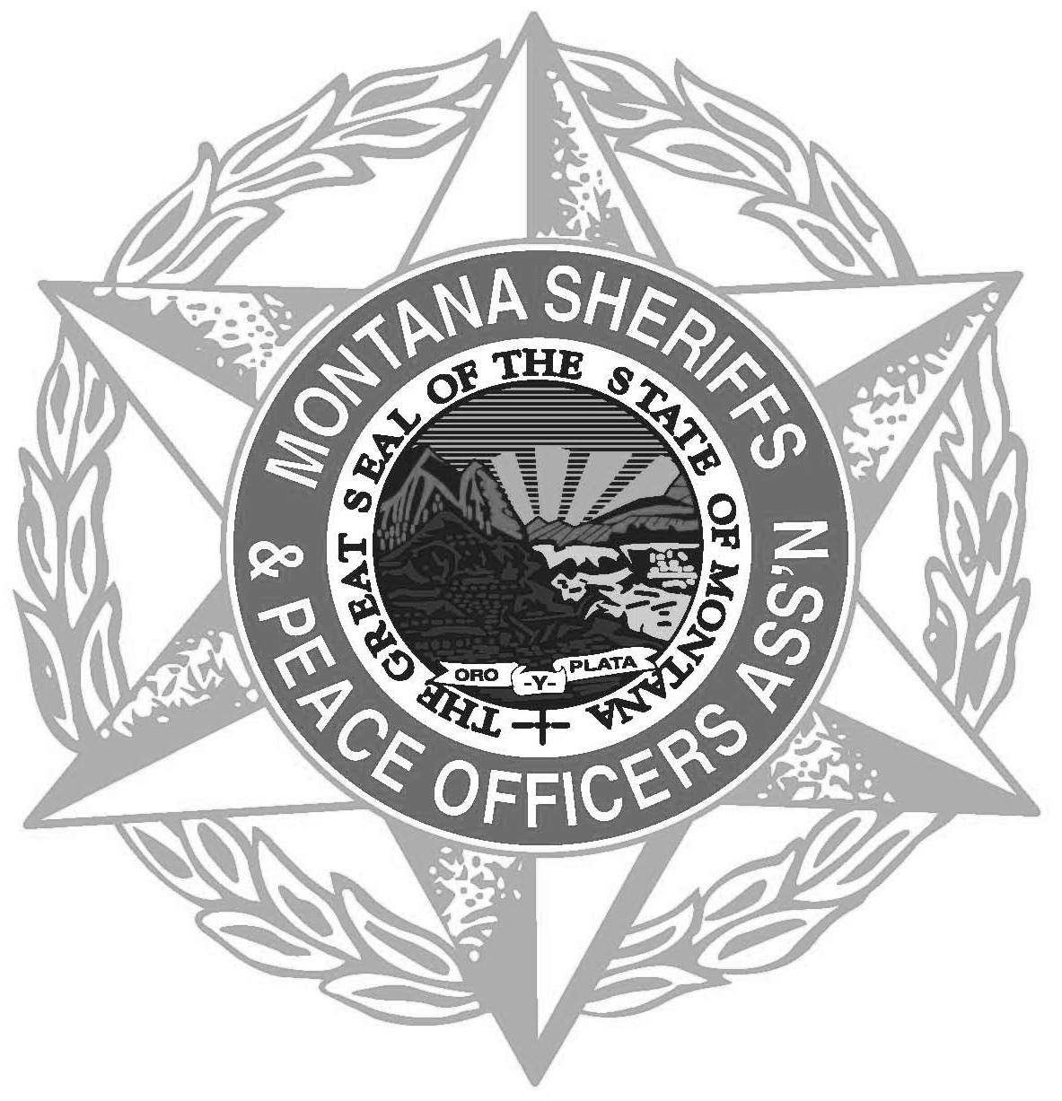
Montana Sheriffs & Peace Officers Association
PO Box 794 • Helena, MT 59624 • (406) 443-5669 • www.mspoa.org

Application Deadline: April 15, 2022

Scholarship Application for children of MSPOA Members. Parent must be a current MSPOA member in good standing. Three Scholarships of $500 will be awarded to three separate members’ children. The scholarship recipients will be randomly chosen and are not merit based. The scholarship funds are for higher education.

The Scholarship award winner(s) check for $500.00 will be issued, in the applicant’s name, and forwarded to the college/university in which he/she is enrolled.

Name of Applicant:

Applicant’s Home Address:

Applicants Home Phone: Email:

Name of Applicant’s Parent:

Parent’s Law Enforcement Agency:

Parent’s Email:

Send Nominations to:
Sheriff Wynn Meehan MSPOA Administrative Office
Broadwater County Sheriff’s Office c/o Nanette Gilbertson
519 Broadway AND P.O. Box 794
Townsend, MT 59644 Helena, MT 59601
wmeehan@co.broadwater.mt.us nanette@smithandmcgowan.com

