Montana Sheriffs and Peace Officers Association
2 0 1 8 C O N V E N T I O N

June 19 - 22, 2018
Billings Hotel and Convention Center  Billings, Montana

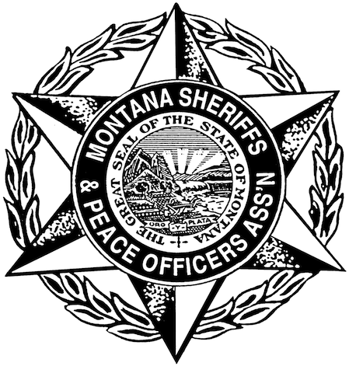
-- Draft Agenda –
POST Credit Pending
All training open to law enforcement and detention officers

Tuesday, June 19, 2018 – Detention Focused Training, MSPOA Board Meeting, Opening Ceremony
0700 Breakfast on your own

0700 – 0800 Registration

0800 – 1200 Legal and Liability Issues in Montana’s Detention Facilities
4 POST Credits Presented by Kevin Gillen, Chief Civil Litigator, Yellowstone County Attorney’s Office

1200 – 1300 Lunch
Provided for all Registrants

1300 – 1700 Legal and Liability Issues in Montana’s Detention Facilities, continued
4 POST Credits Presented by Kevin Gillen, Chief Civil Litigator, Yellowstone County Attorney’s Office

1600 – 1800 MSPOA Board Meeting

1815 – 2000 Opening Ceremony. Vendor Showcase in the Exhibit Hall. Appetizers & Cash Bar.

Wednesday, June 20, 2018 – General Training, Exhibit Hall, Operation LifeSaver BBQ, Golf Calcutta
0700 Breakfast on your own

0700 – 0800 Registration

0800 – 1130 Performance Under Extreme Stress: Implications for Training & Investigations
3.5 POST Credits Presented by Alexis Artwohl, Ph.D.

1200 – 1300 Lunch
Provided for all Registrants

1300 – 1700 Performance Under Extreme Stress: Implications for Training & Investigations
4 POST Credits Presented by Alexis Artwohl, Ph.D.

1800 – 2000 Operation LifeSaver BBQ

2030 – 2230 Golf Calcutta

Thursday, June 21, 2018 – General Training, Golf/Bowling, Annual Banquet
0700 Breakfast on your own

0700 – 0800 Registration

0800 – 0945 DNA Evidence
1.75 POST Credits Presented by Joseph Pasternak, DNA Supervisor, MT Crime Lab

1000 – 1145 Stress Management ~ The Great Falls PD Model
4 POST Credits Presented by Sgt. Rob Beall and Sgt. Rich Labard

1145 Box Lunch
Provided for all Registrants

1230 – 1700 MSPOA Golf and Bowling Tournaments

1800 – 1900 No Host Cocktail Reception

1900 – 2100 Annual Awards Banquet

Friday, June 22, 2018 – Annual Business Meeting, Gun Give Away, MSPOA 30-Gun Raffle
0700 Breakfast on your own

0800 – 1200 MSPOA Annual Business Meeting
Presentations from Local, State and Federal Partners
Gun Give Away and Annual 30-Gun Raffle

1200 Adjourn

